Segmentation of MRI Brain Image With SVM

He

Department of Computer Science Troy University

Troy, USA [hwang176539@troy.edu](mailto:hwang176539@troy.edu)

***Abstract*—Medical image is an important auxiliary tool in diagnosis and treatment, and medical image segmentation is the core and difficulty in medical image analysis. Medical images have the characteristics of small samples, high-dimensional nonlinearity, etc., so it is suitable to use support vector machines to solve segmentation problems. Therefore, this article uses traditional classification method, svm, to solve the multi- classification problem and segment the MRI medical brain image. Use LBP and Haralick texture to do feature extraction, use matlab and python for image preprocessing, train svm classifier and predict.**

**Key words—*SVM, medical image segmentation, MRI***

1. INTRODUCTION

The amount of information about medical images in the world is more than 1/5 of the total information in the world. And medical images are widely used and researched because of their clarity and auxiliary diagnosis and treatment. There are many widely used imaging technologies including X-ray, CT and MRI, which make the information contained in medical images become more comprehensive and clearer. And they are conducive to people's pathological analysis through images targeted, accurate, and low-risk.

Medical image segmentation is not only the initial step of medical picture analysis, but also the key grounds for subsequent research, tumor detection and medical care, the result of image segmentation will directly affect the following steps such as feature extraction and target recognition.[1] Its purpose is to segment some parts of medical image and extract relevant features to make a diagnosis. Traditional classification methods based on statistical theory have been well developed in image segmentation. Vapnik as early as the 60th century begin to study machine-learning issues for not quite much number of samples[2]. Among them, svm is a typical machine learning classification method that specializes in small samples and high-dimensional nonlinearity, which can effectively be use to segment medical images.

In this paper, LBP and Haralick pattern trait are used for pattern extraction, and the classic method svm is used to segment MRI brain images, which will make further understand about the application of svm in multi- classification problems.

1. *SVM SOLVES MULTI-CLASSIFICATION PROBLEMS .*

In recent years, researchers have combined for specific applications, a lot of work has been done for the segmentation of multi-target images, and many algorithms have been

proposed. Gary et al. [3] proposed a topology-constrained geometric deformation model method for segmentation of brain tissue images containing multiple targets; Freedman et al. [4] proposed a distributed matching shape model method for CT images containing multiple targets segmentation research. Reddick et al. [5] used a computer system model method to study the segmentation of magnetic resonance brain tissue images.

The SVM algorithm was originally developed for binary categorization difficulties. When dealing with multi-class problems, it is necessary to place appropriate multi-level classifiers. By choosing appropriately function subset and the discriminant function according to the small amount of sample for the purpose of minimizing the risk and obtain the best generalization performance[6-7]. At present, the commonly used multi-class support vector machine methods mainly fall into two categories: one-to-many methods and one-to-one methods.

1. *One-versus-rest.*

One-versus-rest[8-9] is that during training The rest of the primary antibody [8-9] is during the training period, samples of a specific category are classified into the other category, while the rest of the samples are classified into another category so that K category constructs K support vector machine samples (Fig1) In classification, the unknown sample is classified into the category with the largest classification function value.



SVM krest

1

SVM k-1rest

2

SVM k-2rest

3

SVM k-3rest

Fig. 1. One-versus-rest

1. *One-versus-one*

One-against-one[8-10]is to ‘invent an SVM between any two kinds of samples, so k(k-1)/2 SVMs needed to be created for k kinds of samples. When classifying an unknown sample, the category with the most votes is the

category of the unknown sample(Fig 2). In practice, the disadvantage is that it needs to be constructed and increase the number of binary classifiers relative to the quadratic function in the k test, so that the total training time and testing time are relatively slow. Therefore, many of the scholars try to improve this method.

Abe et al. [11] improved the one-to-one method and proposed a vague support vector machine for multi-class problems. The minimum operator is used to define the membership degree of the vector in the indivisible region, and finally its category is determined according to the membership degree. Tsujinishi et al. [12] modified the method proposed by Abe, replacing the least operator with the mean operator to define the fellowship degree of the vector in the indivisible region, but experiments show that replacing the minimum operator with the average operator will make the classification accuracy Getting worse. Although the above method solves the problem of regional inseparability, it is more complicated to implement due to the need to define the membership function. In this paper, we adapt the one-versus-one method and the SVC function is based on libsvm.

SVM 1-4

SVM 1-3

SVM 2-4

SVM 1-2

SVM 2-3

SVM 3-4

1

2

3

4

Note 4

Note 1

Note 3

Note 2

Note 2

Note 3

Note 4

Note 3

Note 2

Note 1

Note 4

Note 1

Fig. 2. One-Versus-one

# Ⅱ. PICTURE SELECTION AND PREPROCESSING

There are two reasons about select medical image as the segmentation object. For one thing, it is a hot spot and important thing about segmentation of medical image. For another, compared with ordinary images, medical images are inevitable to have the characteristics of blurry edges and uneven gray levels in the regions. In addition, there are great differences between individuals, and the same organization of different individuals is difficult to describe with a unified model, which brought difficulties to the correct segmentation of medical images [13]. Therefore, it is suitable to use support vector machines to solve such small samples, high- dimensional nonlinearity problems.

1. *Images selection*

The medical images are selected from the online simulation image dataset Brain Web of McConnell Center for Brain Imaging, McGill University (). Brain MRI data simulated based on two anatomical models: normal and multiple sclerosis, and three sequence simulations (T1, T2, and proton density-(PD-) weighted) that have been used in data volume and various slice thicknesses, noise Level, and the level of intensity non-uniformity. A discrete anatomical model is provided. Each voxel in the class label represents the tissue most helpful to that voxel (Table I).

-

TABLE I. THE LABLE OF COMPOSITION

|  |  |
| --- | --- |
| Label | Composition |
| 0 | Background(0) |
| 1 | CSF(26-89) |
| 2 | Grey Matter(78-132) |
| 3 | White Matter(124-150) |
| 4 | Fat |
| 5 | Muscle/Skin |
| 6 | Skin |
| 7 | Skull |
| 8 | Glial Matter |
| 9 | Connective |

Because T1-weighted images can provide higher resolution data without increasing the acquisition time, and maintain highly the characteristics of soft tissue contrast and low noise. So this article sets imaging parameters like this:Modality=T1, Slice_thickness=1mm, Protocol=ICBM,Phantom_name=normal, , intensity, Noise=0%, non- uniformity(RF)= 0% (Table Ⅱ). Finally, a three-dimensional image of 187*217*181 is obtained, and the position on the coordinate axis is(-90,-126,-72).

TABLE II. THE SIMULATION IMAGE PARAMETER SELECTION

|  |  |  |  |  |  |
| --- | --- | --- | --- | --- | --- |
| Modality | Slice thickness | Noise | Intensity non-uniformity (RF) | Protocol | Phantom_name |
| T1 | 1mm | 0 | 0 | ICBM | normal |

1. *Image preprocessing*

1)Picture layering. The image preprocessing is mainly to use Matlab to layer the MRI brain image stored in raw byte format to obtain 181*217*181 data, and then convert it into an array of 181*217 rows and 181 columns, and then we will get 181 pictures. In order to see the image, it is necessary to render the pixel value: 1:100; 2:200; 3:255 to get a clear and visible brain image(Fig 3).

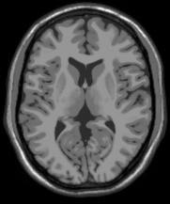

Figure. 3. Brain image 85#

* 1. 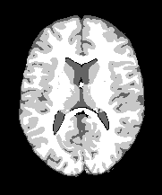Label classification. Normal brain tissue is mainly composed of white matter, gray matter and cerebrospinal fluid(CSF). Cell bodies mainly gather on the surface of the brain, so the darker color is gray matter, while nerve fibers gather inside the brain, so the lighter color is white matter, and cerebrospinal fluid is a colorless and transparent liquid that fills the ventricles and arachnoid membranes inferior cavity and central canal of spinal cord. We will segment the normal brain tissue according to the labels about background, white matter, gray matter, and cerebrospinal fluid, and take out the coordinates of the 0, 1, 2, and 3 labels, and set the rest to 0 for classification processing (Fig 4).
  2. invariance. Earliest LBP operator is defined in the 3 × 3 window. Ccenter pixel is used as a threshold, and compares the gradation value of adjacent eight pixels. If the surrounding pixel value is greater than the center pixel value, the marked position is 1; otherwise it is marked as 0. After this, it is possible to obtain an 8-bit binary number, the value of the central pixel LBP used as a window to reflect this texture information of the 3 × 3 area.
  3. However, 3×3 area evidently cannot meet the demand of extracting texture features of different sizes. For the purpose of adapting to texture features of different scales and meet the requirements of gray and rotation immutablity. Ojala improved the LBP operator by extending the 3×3 neighborhood to any neighborhood, and replacing the square neighborhood with a circular neighborhood area.
  4. Its formula is shown in the figure, where p represents the p-th pixel in the 3×3 window except for the central pixel; I(c) represents the gray value of the central pixel, and I(p) represents the p-th pixel in the field The gray value of each pixel, s(x) function means that when it is greater than or equal to 0, the value is 1; otherwise, the value is 0.

(1)

Fig. 4. Brain image Processed 85#

# Ⅲ. BUILD A SVM CLASSFIER

When building the svm classifier, we use python to run the



2)Haralick texture features

(2)

program. This article will segment the brain image according to the steps shown in flowchart 4.1. The first step is feature extraction, and then divide the training set and test set. The third step is to train the SVM classifier. The fourth step is to predict the trained classifier. The fifth is to evaluate the effect of segmentation.

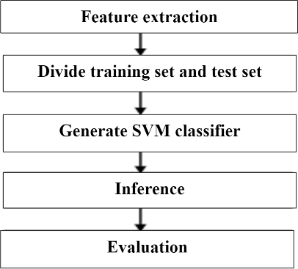

Figure. 5. Flow chart of brain image segmentation algorithm using svm classifier

1. *Feature extraction.*
   1. *Round Local Binary Pattern( Round LBP)*

*For relatively smooth images, such as medical images, some local texture features can be used to obtain better segmentation results[14-15]. LBP is used to describe the operation of the image texture features. This is a local texture features of the T. Ojala, M.Pietikäinen D. Harwood, and to extract the image was first filed in 1994. It has significant advantages such as rotation invariance and gray*

Haralick texture features in the early 1970s put forward by R. Haralick and so on. It is recommended that a comprehensive method of texture analysis under the premise of the relationship include texture information on the space between the pixels in the image distribution.

It assumes that any point (x, y) and a point (x + A, Y + b) in the image are formed point-to-far. Assuming that the gray value of the point pair is (F1, F2), and the maximum gray level of the assumed image is L, there are L combinations of L * f1 and f2. For the entire image, count the number of occurrences of each value of (F1, F2), then arrange them into a square matrix, and then use the total number of occurrences of (F1, F2) to normalize them to the probability of occurrence P (F1, F2), the matrix obtained is the gray-level co-occurrence matrix.

Haralick then described that the 14-point statistics can be calculated from the intent of the co-occurrence matrix to describe the texture of the image.There are partial of them used in this paper.

* Contrast: It reflects the clarity and texture of the image and the depth of the groove. Texture, the greater the contrast, the clearer the effect of the deeper grooves; on the contrary, the smaller the contrast, the shallower grooves and the blur effect
* Angular Second Monent:Energy transformation Reflect the intensity distribution of a uniform thickness and texture of the image. If the element values of the gray-

level co-occurrence matrix are similar, the energy issmall*,* which *means the* texture *is finer; if a few of the* values are huge and the others are trivial, the energy

value is huge. A large energy value shows a more uniform and regular texture pattern.

* Entropy: The image consists of a measure of the randomness of the amount of information. When all the values in the co-occurrence matrix are equal or

𝐶𝑜𝑟𝑟𝑒𝑙𝑎𝑡𝑖𝑜𝑛 =

∑𝑗(𝑖𝑗)𝑝(𝑖,𝑗)−𝜇𝑥𝜇𝑦

𝜎𝑥𝜎𝑦

(3)

thepixelvaluesshowthegreatestrandomness*, the* entropy is the largest; Thus, the complexity of the image entropy represents gray scale distribution. Entropy higher the value, the more complex images.

* Inverse Different Moment：Reflect local variations in the size of the image texture. If different regions of the image texture is more uniform and changes slowly, the inverse of variance will be larger, and vice versa.
* Correlation：It is used on the gray level similarity measurement image row or column direction. Therefore, the value reflects the local gray correlation. The larger the value, the greater the correlation.

In the end ,we will get the feature vector size: 103200, 13.

𝑐𝑜𝑛 = ∑𝑖 ∑𝑗(𝑖 − 𝜇)2𝑝(𝑖. 𝑗) (3)

𝐴𝑆𝑀 = ∑𝑖 ∑𝑗 𝑝(𝑖, 𝑗)𝑙𝑜𝑔 (𝑝(𝑖, 𝑗)) (4)

* + 1. Selection of training set and test set.

The choice of the number of training samples has a certain impact on the classification results. Too few samples will lead to insufficient learning and large errors; too many samples will not only increase the training time, but also cause over learning. Therefore, the image is randomly divided into training set, validation set and testing set according to the ratio of 7:2:1. Remove the unclear and useless pictures, the final sample size is 144.

* + 1. Adjust parameter Penalty coefficient error term. The larger C is, the greater the penalty is the wrong sample, so the higher the accuracy in the training sample, but the generalization ability is reduced, that is, the classification accuracy of the test data is reduced. On the contrary, if C is lowered, some misclassified samples are allowed for training samples, and the generalization ability is strong. In this paper, when C rising, the progressing time becomes shorter, and the accuracy is advanced in a small limited.

TABLE Ⅲ. RESULTS OF DIFFERENT PARAMETERS

|  |  |  |  |  |
| --- | --- | --- | --- | --- |
| kernel=rbf degree=3 gamma=0 |  | C | | |
| 0.8 | 1 | 10 |
| Progressing time | 3108.931 | 3007.970 | 2957.826 |
| Prediction | 0.86 | 0.86 | 0.87 |
| Recall | 0.92 | 0.93 | 0.94 |
| Accuracy | 0.85 | 0.86 | 0.87 |
| F1 value | 0.89 | 0.89 | 0.90 |

* + 1. Segmentation Result. As a traditional method, svm although takes a long time in medical image segmentation, the accuracy is 87%, which is a relatively satisfactory result. Compared The predicted result image with the Grown truth image, svm is more accurate in the segmentation of CSF, but the gray matter and white matter segmentation is poor. That is Because gray matter and white matter are relatively close to the grayscale characteristics, at the same time, the grayscale difference between CSF and gray matter and white matter is greater.

From the results, support vector machine is also a better, simple and easy-to-understand method when multiple classification problems such as blurred target boundaries, uneven target gray levels, and discontinuous targets occur.

TABLE Ⅳ. CLASSIFICATION EFFECT of SVM CLASSFIER

|  |  |
| --- | --- |
| Prediction | 0.87 |
| Recall | 0.94 |
| Accuracy | 0.87 |
| F1 value | 0.90 |

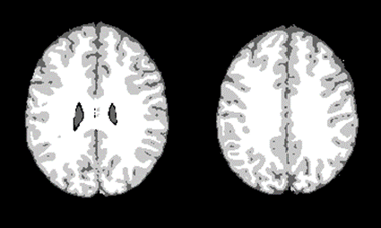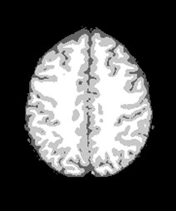

Fig5, Ground truth

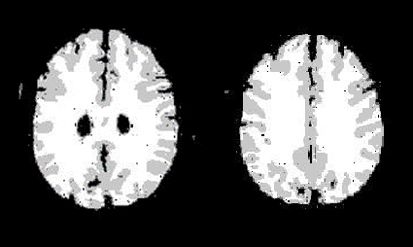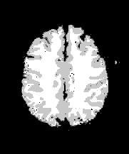

Fig6, Prediction

# Ⅳ. FUTURE WORK

The support vector machine seeks the best compromise between the complexity of the model (that is, the learning accuracy of a specific training sample, Accuracy) and the learning ability (that is, the ability to recognize any sample without error) based on limited sample information, in order

to obtain the best Good generalization ability (Generalizatin Ability).

However, with the further development of deep learning and imaging technology, medical image segmentation will used the Convolutional Neural Network method, such as U- Net[17],CE-Net[18]. More importantly, it is proposed from the perspective of improving the function decoder, function encoding and decoding based on the convolutional recurrent neural network method. It contains a novel feature fusion unit called Recursive Decoding Unit (RDC), which uses a convolutional regression neural network to memorize long-term context information from the layers before the decoding stage.On the basis of RDC, a network of coding and decoding structure is also designed, called Convolutional Recurrent Decoding Network (CRDN), which is used to segment multimodal medical images[19-20].

Contrast with the deep learning, svm has been a time- consuming and low-precision algorithm in medical image segmentation. Through experiments, we can still see the main advantages of the VC dimension theory based on the statistical learning theory and the support vector machine based on the principle of minimum structural risk: (1) It can solve the machine learning problem in the case of small samples (2) It can improve the generalization Performance

(3) can solve high-dimensional problems (4) can solve non- linear problems (5) can avoid neural network structure selection and local minima problems. At present, SVM algorithm has applications in many fields. For example, in the aspect of pattern recognition, it is used for handwritten digit recognition, speech recognition, facial image recognition, article classification, etc. The SVM algorithm has exceeded or is equivalent to the traditional accuracy learning algorithm. fuzzy support vector machine, least two Multiplying support vector machines and other algorithm improvements or building multi-class svm based on hierarchical clustering and decision tree ideas will add vitality to the wide application of support vector machines in the intelligent era.

# Ⅴ. Comparision of different algorithm

It can be seen from the table that the training accuracy of svm is not as good as rf and gbc. This may be because, one is that the tuning coefficient of svm is not optimal, and the other is that the image we choose is 0 noise, which may be at zero In the case of noise, rf performs better than svm, but the brain image in reality is noisy. The classification characteristic of rf, that is, a single decision tree is very sensitive to data changes, which may cause over-fitting problems and ultimately affect segmentation effect.

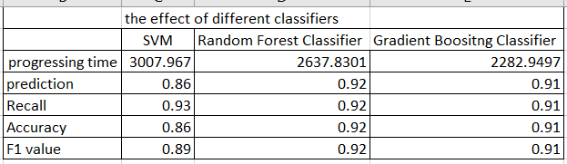

REFERENCE

1. C. Yan, N. Sang and T. Zhang. Local entropy-based transition region extraction and thresholding. Patter Recognition Letters, 2003, 24: 2935~2941
2. I. Middleton and R.I.Damper. Segmentation of magnetic resonance images using a combination of neural networks and active contour models. Medical Engineering & Physics, 2004, 26: 71~86
3. H.P.Gary and P.C. Shi. Domain partitioning level set surface for topology constrained multi-object segmentation. IEEE International Symposium on Biomedical Imaging, 2004: 1299~1302
4. D.Freedman. Model-Based Multi-Object Segmentation via Distribution Matching. Conference on Computer Vision and Pattern Recognition Workshop, 2004: 1299~1302
5. W. E. Reddick, J.O. Glass, E. N. Cook et al. Automated segmentation and classification of multispectral magnetic resonance images of brain using artificial neural networks. IEEE Transactions on Medical Imaging, 1997, 16(6): 911~918
6. V. Vapnik. The nature of statistics learning theory. New York: Springer Verlag, 1995.
7. V. Vapnik. Statistical learning theory, New York: J. Wiley, 1998
8. C. W. Hsu and C. J. Lin. A comparison of methods for multi-class support vector machines. IEEE Transactions on Neural Networks, 2002, 13(2): 415~425.
9. J. Weston and C. Watkins. Multi-class support vector machines. Technical Report, 1998, CSD-TR-98-04: 1~9.
10. U. Kre Bel. Pairwise classification and support vector machine. in Advances in Kernel Methods-Support Vector Learning, Cambridge, MA: MIT Press, 1999: 255~268.
11. S. Abe and T. Inoue. Fuzzy support vector machines for multiclass problems. Proceedings of the Tenth European Symposium on Artificial Neural Networks, 2002: 113~118.
12. D. Tsujinishi and S. Abe. Fuzzy least squares support vector machines for multiclass problems. Neural Networks, 2003, 16: 785~792.
13. A logarithm-based image denoising method for a mixture of Gaussian white noise and signal dependent noise[J] . Xinjian Wang,Guangyi Chen,Guangchun Luo. <journal-title>Journal of Intelligent & Fuzzy Sys . 2017.
14. D. R. Chen. Diagnosis of breast tumors with sonographic texture analysis using wavelet transform and neural networks. Ultrasound in Medicine and Biology, 2002, 28(10): 1301~1310.
15. Improving airway segmentation in computed tomography using leak detection with convolutional networks[J] . Jean-Paul Charbonnier,Eva

M. van Rikxoort,Arnaud A.A. Setio,Cornelia M. Schaefer-

Prokop,Bram van Ginneken,Francesco Ciompi. Medical Image Analysis . 2017.

1. [http://murphylab.web.cmu.edu/publications/boland/boland_node26.ht ml.](http://murphylab.web.cmu.edu/publications/boland/boland_node26.html)
2. O.Ronneberger, P.Fischer, T. Brox. U-net. Convolutional networks for biomedical image segmentation[C]//International Conference on Medical image computing and computer-assisted intervention. 2015: 234-241.
3. Z. Gu, J.Cheng, H. Fu, et al. Ce-Net: Context Encoder Network for 2D Medical Image Segmentation[J]. IEEE transactions on medical imaging, 2019.
4. *X.*He, S.Yang, G. Li, et al. Non-Local Context Encoder: Robust Biomedical Image Segmentation against Adversarial Attacks[C]//Proceedings of the AAAI Conference on Artificial Intelligence: Vol 33.2019:8417-8424.
5. H.Zheng,L. Yang. Chen, et al. Biomedical image segmentation via representative annotation[C]//Proceddings of the AAAI Conference on Artificial Intelligence : Vol 33.2019:5901-5908.